Honest Signal and Personal Analytics

Honest signals are parameter that humans cant fake without special training therefore they make up excellent measure of human behaviour. These signals have immnese potential to predict outcome of social situiation like date, interview, project proposal, negotiation etc. These signals are result of extensive study done at MIT media lab by Prof. Alex Sandy Pentland, director of Human dynamics group.

What are Honest Signal?

1)Influence: The amount of influence each person has on another in a social interaction. Influence is measured by the extent to which one person causes the other person’s pattern of speaking to match
their own pattern.

2)Mimicry: The reflexive copying of one person by another during a conversation, resulting in an unconscious back-and-forth trading of smiles, interjections, and head nodding during a conversation.

3)Activity: Increased activity levels normally indicate interest and excitement, as seen in the connection between the activity level and excitement in children, or when male orangutans shake branches in order to impress potential mates.

4)Consistency: When there are many different thoughts or emotions going on in your mind at the same time, your speech and even your movements become jerky, unevenly accented and paced.
The consistency of emphasis and timing is a signal of mental focus, while greater variability may signal an openness to influence from
others.

Humans can sense these signals unconsiously and make decision based on that. These signals were used in predicting the outcome of buisness plan pitching competition at MIT Sloan school of Buisness. By using camera and audio recorder embedded into a device known as sociometer they were able to predict the outcome of competition with correlation r=0.6 and probability p<.01

People in real-life situations employ combinations of honest signals rather than using them individually. These combinations cluster in characteristic ways to signal the social role that the person has adopted the attitudes, intentions, and goals that characterize typical types of
relationships between people. To illustrate how honest signals communicate social roles, I will
start with the central interpretation of each of our honest signals. Let’s say that influence signals attention, mimicry signals empathic understanding, activity level signals interest, and consistent emphasis signals mental focus and determination (and hence inconsistent or variable emphasis signals a possible openness to influence).

Because people have this capability for automatic signaling and response, the signaling of each person can propagate through the chains of people that make up their social network, eventually
changing the behavior of the entire group. So when a group of people gets together, we need to consider not just the individual behaviors but also the social circuits formed by the patterns of
signaling between them. These social circuits specify networks of dominance, obligation, friendliness, attention, and receptivity, which in turn coordinate the day-to-day behavior of the
group.
For instance, in the Stanford University experiment discussed above that used a computer-animated sales agent to mimic people, researchers found that mimicry makes the agent seem both more
honest and more persuasive. The interesting thing is that this is only half of the story: when someone mimics you, there is a very strong tendency for you to begin mimicking them. This creates a sort of social circuit that reinforces itself, producing a pair of people deeply engaged in mimicking each other, and each feeling better and better about the other person.

Honest signals have evolved to coordinate individual behaviors in the midst of competition. In groups, though, competition is not just a one-on-one situation. There are instead competing coalitions supporting different alternatives, with the membership of the coalition shifting with each different question or new idea. Consequently, participants take on many different roles in quick succession, each with its own characteristic signaling display

How did primitive humans make group decisions? With only limited language skills, the decision process couldn’t really involve logical argument. For that matter, how do ape groups decide what
to do? With language removed from the equation, some way must still exist to gather and assess the possibilities for group action, and make group decisions that maximize rewards and minimize risk.
There also has to be a way for each individual to know what the group decided, so that everyone can play their respective roles. This evolutionary advantage would result in the selection of the
types of network intelligence that produced the most accurate and reliable decision making. As such, the signaling and circuitry that occur in primitive human groups may tell us a great deal about
what sorts of group decision making we are naturally good at and how to promote effective decision making in modern-day organizations.

What controls the pattern of communication within the social network? Within a face-to-face meeting, attention and interest, signaled by influence on the conversational turn taking and activity
level, are critical in shaping the pattern of communication. People who are paying attention to each other tend to coordinate their activities (which we can measure as influence), and people who are interested spend more time talking together (a measure of activity). Consequently, people who are working together are more likely to stop to talk in the hall, go for lunch, get coffee, go out for
a drink, and so forth, thereby influencing each other’s pattern of communication.

Device that people at MIT Media lab came up with to measure these signals was Sociometer. A sensor-based feedback system for organizational computing consists of environmental and wearable sensors, computers, and software that continuously and automatically measure individual and collective patterns of behavior, identifies organizational structures, quantifies group dynamics,
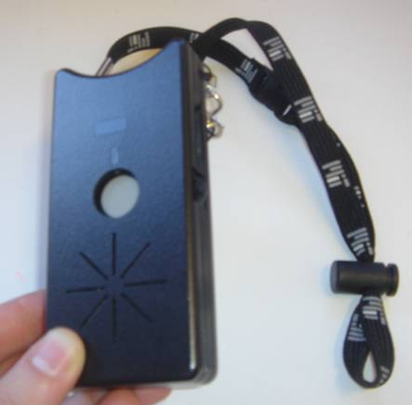
and provides feedback to its users. The purpose of such a system is to improve productivity, efficiency, and/or communication patterns within an organization.

The Sensors that were used in making Sociometer are available in Present day SmartPhones. This idea has tremendous app potential in personal, organization and group sensing application. With google glass about to launch in 2014, developer are pacing to come up with app that are compitable with glass. Glass opens possiblity of new range of application that were not possible with mobile phone. With the power of computation combined with wearable gadget reality mining is becoming more real.

Fig 1.1: Sociometer

Reference:
- Capturing Individual and Group Behavior with Wearable Sensors , Daniel Olgu ́n
- Tosi, H. L.; Mero, N. P.; and Rizzo, J. R. 2000. Managing Organizational Behavior. Cambridge, MA: Blackwell Publishers Inc.
- Honest Signal By Alex Sany Pentland,Human Dynamics Research MIT Media Laboratory Cambridge, MA 02139 ,pentland@media.mit.edu
- N. Eagle, A. Pentland, and D. Lazer (2009), "Inferring Social Network Structure using Mobile Phone Data", Proceedings of the National Academy of Sciences, 106(36), pp. 15274-15278.

